

Classic cocktails. Abstract nights. North side energy.

Andersonville, Chicago
1478 W Catalpa Avenue · Chicago, IL 60640

01
Color
Deep, dim-lit tones read as the room itself — copper light against a dark, art-forward space. Cream carries text; copper is the primary accent, and the teal sampled from the logo background is used sparingly as a second accent.

Ink  Background & Primary Surface  oklch (13% 0.008 240) |  | Surface  Cards, Raised Panels  oklch (19% 0.012 240) |  | Cream  Primary Text on Dark  oklch (94% 0.015 85)
Muted  Secondary Tex, captions  oklch (65% 0.015 230) |  | Copper  Primary Accent – CTAs, prices  oklch (66% 0.13 50) |  | Teal  Secondary Accent  oklch (33% 0.063 233)

02
Typography
Libre Caslon Display sets headlines — editorial, a little dramatic. Manrope carries everything functional. Libre Caslon Text italic is reserved for voice: quotes and taglines.

Display / Libre Caslon Display
Poured cold.
72-96px · headlines · sections · titles

Display / Libre Caslon Display
Classy. Sass. Definitely bad assy.
28-40px · Quotes · Taglines · Voice Moments

Body / Manrope  Manrope 700  Nav · Buttons · Prices | Body / Manrope  Manrope 500  Subheads · Labels | Body / Manrope  Manrope 400  Body Copy · Descriptions

03
Logo
A script wordmark paired with a martini glass mark and tracked-out lockup type. Cream on dark is primary; ink-on-cream is the sole reversal.
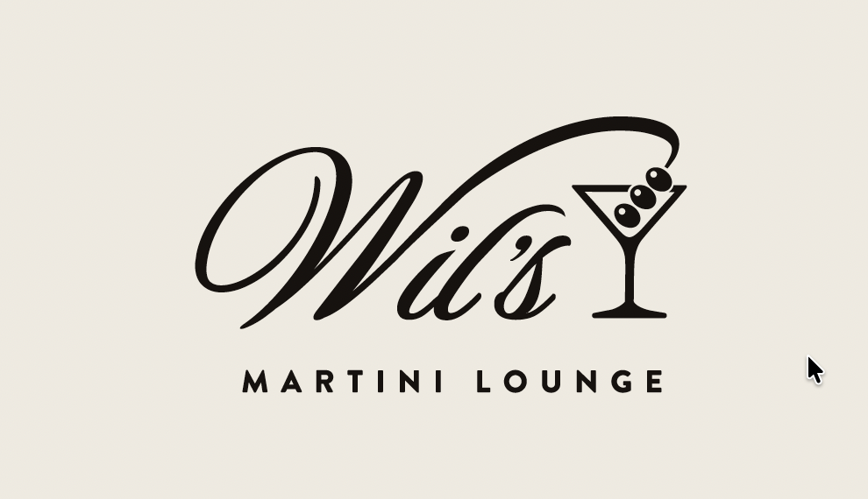
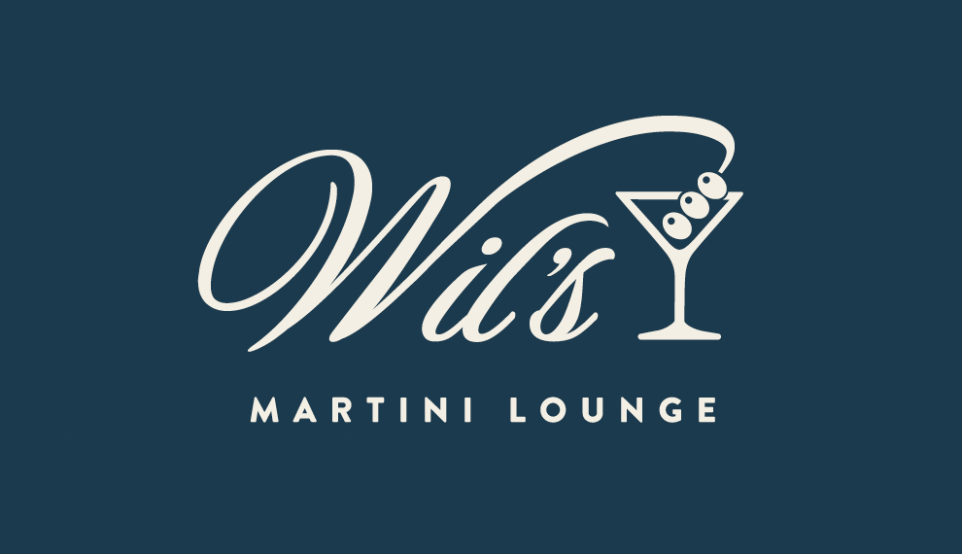

Clear space: keep at least the height of the "M" in MARTINI LOUNGE clear on all sides.
Never recolor the script, skew the glass, or reset the lockup type in anything but Manrope uppercase, tracked wide.

04
Buttons & Tags
One filled action per view. Outline for secondary. Tags mark menu categories — Signature, Classic, seasonal features.

View Menu |  | Visit Us |  | Reserve a table
SIGNATURE |  | CLASSIC |  | FALL FEATURE

05

Drink Card
The core menu component. Tag, name, ingredients, two-pour pricing – 10 oz / 6 oz

SIGNATURE  Charlie’s Cosmo  Botanical grapefruit and rose vodka, triple sec, cranberry juice, and lime juice with a lemon twist  $18 / $13 |  | CLASSIC  Espresso Martini  Vanilla vodka and coffee liqueur, with a coffee bean garnish.  $17 / $12 |  | FALL FEATURE  The Veteran  Whiskey, honey, sour mix, and cardamom bitters, with an orange garnish.  $18 / $13

06

Drink Card
For guest reviews and neighborhood voice.

“Absolutely fell in love with this place and the staff!
Best martinis in Chicago!”
- KHENEMET, NEIGHBORHOOD GUEST

07

Template - Hero
Applied composition for a landing hero.

ANDERSONVILLE, CHICAGO
Classic cocktails. Abstract nights. North side energy.
View Menu |  | Visit Us

08
Template – Hours & Location

HOURS  Monday – Thursday 4pm – 1am  Friday & Saturday 3pm – 2am  Sunday 24pm – 1am |  | LOCATION  Wil’s Martini Lounge  1478 W Catalpa Avenue  Chicago, IL 60640  773.247.2135

